API 1: Getting all products using GET

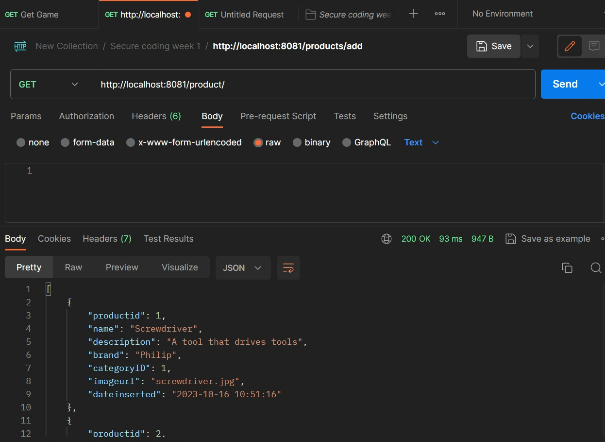

Figure 1: GET

API 2: Insert product using POST

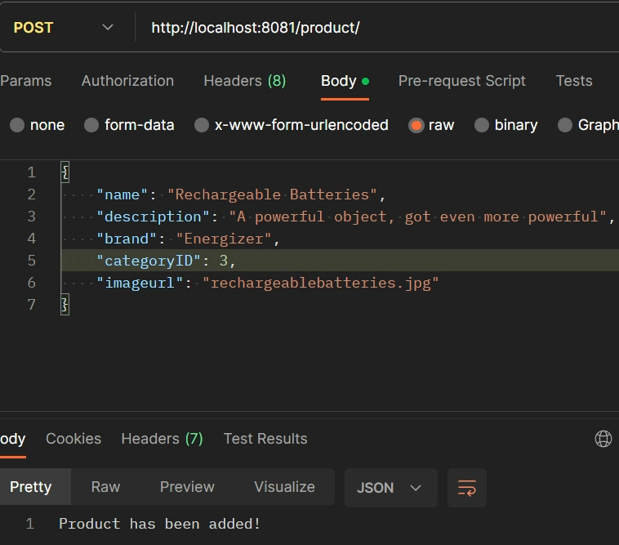

Figure 2: POST

API 3: edit product using PUT

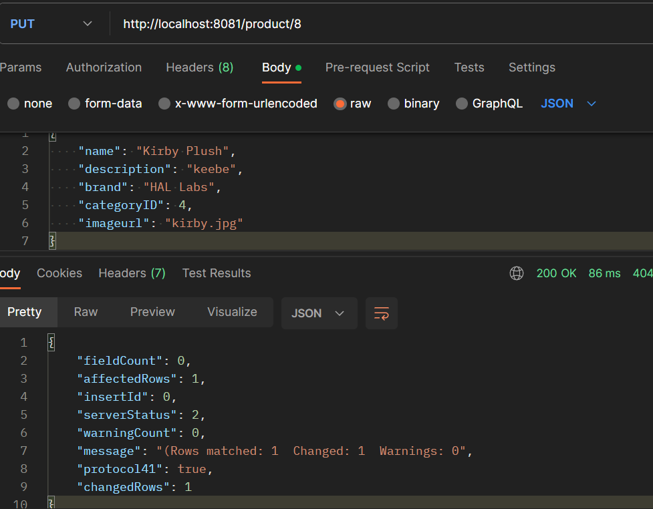

Figure 3: PUT

API 4: Delete product using DELETE

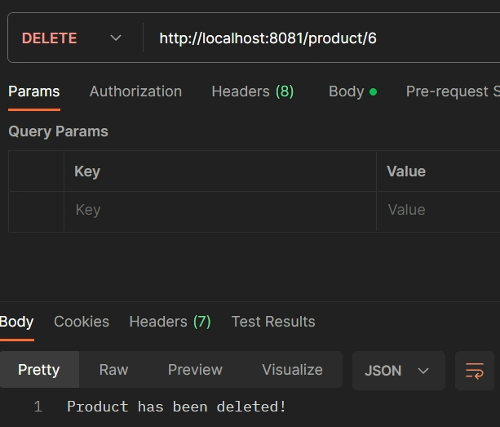

Figure 4: DELETE